Exam Schedule Management System - Ứng dụng quản lý coi thi cho FU HCM (ESMS)

+ Hệ thống cho phép lên lịch trước ngày bắt đầu.

+ Thông báo cho giảng viên và sinh viên qua email trước 24g.

+ Phụ cấp coi thi trong một tháng được tính từ ngày 1 đến ngày 15 của tháng hiện tại. Phụ cấp từ ngày 16 đến cuối tháng sẽ tính cho kỳ lương sau.

+ Thời gian để lên Lịch coi thi trước 7 ngày và thời gian giảng viên không được huỷ lịch là 3 ngày và có thể được cấu hình bởi Admin.

+ Phụ cấp coi thi 1 giờ là 100.000 vnđ và có thể thay đổi trong tương lai.

+ Mỗi ca thi cách nhau 15 phút.

# **SLOT 2, 3: What - Why - Who**

## **Problem:**

At FU HCM, the management of exam schedules for lecturers and students faces many inadequacies as they still have to use notices posted in front of the exam room, and do not apply technology to manage exam schedules, making it difficult to manage exams. Their control and receiving notifications are difficult. This causes many problems in terms of efficiency and reliability in the organisation of exams.

A web-based Exam Schedule Management System offers numerous advantages that significantly enhance the efficiency and effectiveness of educational institutions. By automating the scheduling process, it minimizes the time-consuming and error-prone nature of manual scheduling, reducing the likelihood of scheduling conflicts. Furthermore, it promotes transparency by allowing easy access to schedules for students, teachers, and administrators, preventing misunderstandings and disputes. Accessibility from anywhere with an internet connection empowers students and faculty to view schedules online, diminishing the need for physical notices or inquiries. The system's ability to detect and address conflicts, facilitate communication, and provide real-time updates ensures a smoother exam experience for all stakeholders. Furthermore, it aids in resource allocation, offers valuable data for future optimizations, enhances security, and adapts seamlessly to the growth of educational institutions. Coupled with user-friendly interfaces and the potential for long-term cost savings, such a system becomes an indispensable tool for modern educational organisations, fostering fair and organized exam schedules.

## **Who - what:**

**2.1. Admin:** They can manage the system at the highest level, have access to any information and update the system

**2.2. Lecturer:** They can register to become an exam proctor, they have basic rights such as viewing information about all subjects included in the exam and checking their own allowances

**2.3. Student:** They have the basic rights to view information about all the exam subjects they participate in, can use information such as exam subjects, exam dates and test sessions to search on the exam list and the system allows updates. Update their basic personal information on the system

**2.4. Testing Admin:** Create, manage and monitor exam schedule. Plans, develops, and coordinates testing program policies, procedures and schedules, and ensures adequate staffing for the administration of examinations. Adjust student & instructor information. Monitor allowance by time, by lecturer, by department

**2.5. Testing Staff:** Search and view examinations. Export exam information to Excel file.

## **Interview** (Opened Questions & Closed Questions):

**Opened Questions:**

* Can Testing Admin and Testing Staff be combined into one person?
* Is there a limit to the number of people in each role participating in the system?
* How do you want the system to handle the system when there is a system conflict? (will it be notified and handled directly by Admin or will the system use a handling tool)
* Which steps do you need to do automatically in this system?
* Is there any information that needs synthesising and collecting for each exam session? (e.g. number of students participating/present/absent in the exam)
* Which personal information can a student update? (e.g. name, contact information, password, etc.)

**Closed Questions:**

* Does the ESMS have a notification feature to send alerts to lecturers and students about exam details and changes via email or other means?
* Does the system need to manage exam scores?
* Does the Admin in this project only manage the entire system?
* Will the ESMS support exporting exam information to Excel files for easy data management and analysis by Testing Staff?

# **SLOT 5: Vision and Scope**

Table of Contents

Table of Contents.......................................................................................................... ii

Revision History............................................................................................................ ii

1. Business Requirements............................................................................................ 1

1.1. Background....................................................................................................... 1

1.2. Business Opportunity....................................................................................... 1

1.3. Business Objectives.......................................................................................... 1

1.4. Success Metrics................................................................................................ 1

1.5. Vision Statement.............................................................................................. 1

1.6. Business Risks.................................................................................................. 1

1.7. Business Assumptions and Dependencies........................................................ 2

2. Scope and Limitations.............................................................................................. 2

2.1. Major Features.................................................................................................. 2

2.2. Scope of Initial Release.................................................................................... 2

2.3. Scope of Subsequent Releases.......................................................................... 2

2.4. Limitations and Exclusions.............................................................................. 2

3. Business Context...................................................................................................... 2

3.1. Stakeholder Profiles.......................................................................................... 2

3.2. Project Priorities............................................................................................... 3

3.3. Deployment Considerations............................................................................. 4

## **1.** **Business Requirements**

### **1.1.** **Background:**

At FU HCM, the management of exam schedules for lecturers and students faces many inadequacies as they still have to use notices posted in front of the exam room, and do not apply technology to manage exam schedules, making it difficult to manage exams. Their control and receiving notifications are difficult. This causes many problems in terms of efficiency and reliability in the organisation of exams.

However, after the implementation of support software, everything changed. The benefits of using this software became evident. Firstly, automating many management tasks saves a significant amount of time and effort. Tasks ranging from exam organization to facility management and personnel management became easier and less labor-intensive. The risk of errors also decreased significantly, ensuring the accuracy and reliability of school activities. Furthermore, support software made it easy to track and evaluate the effectiveness of activities accurately. Schools could automatically collect and analyze data, making management decisions based on reliable information. Providing information to students, parents, and staff became quicker and more convenient, creating better conditions for disseminating important information.

In conclusion, support software has brought many significant benefits to the school, from optimizing management and resources to improving the quality and efficiency of activities. This represents a crucial step in enhancing the quality of education and school management.

### **1.2.** **Business Opportunity**

There is a compelling business opportunity in developing and offering a Web-Based Exam Schedule Management System tailored for educational institutions like FU HCM. The prevalent challenges faced by these institutions, characterized by manual scheduling and a lack of technological integration, create a substantial market demand for a solution that can streamline these processes. This system promises to significantly enhance efficiency, transparency, and communication by automating scheduling, providing real-time updates, and facilitating easy access to schedules for students, teachers, and administrators. Additionally, it offers the potential for long-term cost savings and scalability, making it an indispensable tool for modern educational organisations seeking fair and organized exam schedules.

### **1.3.** **Business Objectives**

BO-1: 20% less time spent handling enrollment and examination forms within 12 months following initial release.

BO-2: 30% reduction in printing costs within 2 months of the initial release.

BO-3: Reduce the average time of 15 minutes per lecturer when registering for an exam schedule within 6 months of the initial release.

### **1.4. Success Metrics**

### **1.5.** **Vision Statement**

**For** university administrators at FU HCM, **who** struggle with the antiquated exam scheduling process, **the** FU Exam Management System **is** an Internet-based and smartphone-enabled application **that** streamlines exam scheduling, enhancing efficiency and reliability. **Unlike** the current paper-based system that lacks transparency and efficiency. **Our product** automates scheduling, notification, and control, ensuring a seamless and transparent exam organisation process and saving them time.

**For** students **who** want to see and receive notifications about the schedule of their courses this semester. **The** Exam Schedule Management SystemIs **is** the wed-base and smartphone-enabled. **That** will help you easily search and view all the exams that students must take in their current semester, and easily notify you when you encounter class conflicts. **Unlike** current manual exam scheduling processes. **Our exam schedule management system** helps optimize time, is easy to operate, and is secure and safe.

**For** lecturers at FU HCM **who** need a more efficient way to assign and receive notifications about their invigilation schedules, **the** FU Exam Management System **is** a cutting-edge solution to simplify course scheduling and exam management. This Internet-based and smartphone-enabled tool replaces traditional, paper-based methods, **providing** real-time access to schedules and notifications. **Unlike** current manual scheduling processes, our product streamlines the process, making it easier for lecturers to plan their schedules, ultimately saving them valuable time. **The FU Exam Management System** ensures a seamless and organized experience, enhancing the efficiency of invigilation assignments for lecturers at FU HCM.

# **SLOT 8: Use Case**

**Use Case List**

| Primary Actor | Use Cases |
| --- | --- |
| Admin | 1. Update System  2. Manage Account  3. Authorized Account |
| Testing Admin | 4. Create Exam Slot  5. Mange Exam Slot |
| Testing Staff | 6. Export data to Excel file  7. Get Information about Exam Slot |
| Student | 8. View Profile  9. View Exam Schedule  10. Search Exam Slot |
| Lecturer | 11. View Profile  12. Register to Exam Proctor  13. View Exam Schedule  14. Search Exam Slot |

# **SLOT 9, 10: Business Rules**

**Use Case Template**

| UC ID and Name: | **UC-4 Create Exam Slot** | | |
| --- | --- | --- | --- |
| Created By: | Ngo Gia Huan | Date Created: | 28/09/2023 |
| Primary Actor: | Testing Admin | Secondary Actors: |  |
| Trigger: | Testing Admin indicates that he wants to create exam slot for each subject | | |
| Description: | This use case describes the process Testing Admin creates exam slots for subjects within an examination system. | | |
| Preconditions: | PRE-1. The Testing Admin must be authenticated and logged into the examination system. | | |
| Postconditions: | POST-1. Exam slots for the specified subjects are successfully created in the examination system.  POST-2. The system is updated with the new exam slot information. | | |
| Normal Flow: | 1. The Testing Admin navigates to the "Exam Slot Management" or equivalent section of the system. 2. The system presents a form or interface for creating a new exam slot. 3. The Testing Admin selects the subject(s) for which exam slots need to be created. 4. For each selected subject: 5. The Testing Admin enters the exam date and time. 6. The Testing Admin submits the form to create the exam slots. 7. The system validates the information and confirms the successful creation of exam slots. | | |
| Alternative Flows: | 1. If the system encounters errors during the form submission (e.g., invalid date, time conflicts), it will prompt the Testing Admin to correct the errors and resubmit. 2. If the Testing Admin cancels the operation at any point, the use case terminates without creating any exam slots. | | |
| Exceptions: | 1. If the Testing Admin's session expires or they are no longer authenticated, the system will prompt them to log in again. 2. If there are technical issues or system downtime, the use case may be interrupted, and the Testing Admin will need to retry later. | | |
| Priority: | High | | |
| Frequency of Use: | This use case is frequently used during the exam scheduling period, typically at the beginning of each academic semester or exam cycle. | | |
| Business Rules: | BR-6: Only Testing Admin can create, edit, or delete exam slots.  BR-7: The system enforces a constraint that exam slots cannot overlap in time  BR-8: The system provides a user-friendly interface with date and time pickers to facilitate the selection of exam date and time(quality)  BR-9: Based on the selected exam date and time, the system infers whether there are any scheduling conflicts with existing exam slots  BR-10: The system calculates the maximum capacity of each exam slot based on user input and predefined rules, ensuring that the limit is not exceeded which is config by admin. | | |
| Other Information: | 1. The system shall provide a date and time picker interface for the Testing Admin to select the exam date and time when creating exam slots. 2. The system should allow the Testing Admin to set a maximum capacity for each exam slot, limiting the number of students who can register for a particular exam session. | | |
| Assumptions: | The Testing Admin is knowledgeable about the exam schedule and requirements for each subject.  The examination system is functional and accessible.  Subject information is accurately maintained in the system. | | |

| UC ID and Name: | **UC-6 Export data to Excel file** | | |
| --- | --- | --- | --- |
| Created By: | DAO NGUYEN HUY NHAN | Date Created: | 28/09/2023 |
| Primary Actor: | Testing Staff | Secondary Actors: |  |
| Trigger: | Testing Staff will export Exam slot’s data to Excel file for lecture. | | |
| Description: | When the lecturer goes to watch the exam, they need a paper containing everything about the exam room they will be watching. The Testing Staff is responsible for exporting each data to an Excel file and giving it to the lecture for the exam. | | |
| Preconditions: | PRE-1. Testing Admin logged into ESMS.  PRE-2. Testing Admin access to suitable Exam slot. | | |
| Postconditions: | POST-1. Excel file content data of exam slot.  POST-2. | | |
| Normal Flow: | 1. The system will respond to exam slots available that day. 2. Testing Staff select 3. s the appropriate exam slot and presses the export button. 4. The system will access that exam slot and export all data of that into Excel file. 5. Testing Staff open Excel File and print for Lecture. | | |
| Alternative Flows: | 1. If a lecture provides incorrect or incomplete information about their Exam slot, Testing Staff should inform them of the issue and request the necessary details for export.  2. In case there are multiple Exam slots for the lecture to supervise, Testing Staff will ensure that each slot's data is correctly exported to separate Excel files or separate sections within the same Excel file to maintain clarity and organization.  3. If there are technical issues during the export process, such as system errors or formatting problems, Testing Staff should troubleshoot and resolve these issues promptly. If unable to resolve, they should report the issue to the appropriate IT support personnel. | | |
| Exceptions: | 1. If Testing Admin is unable to log into ESMS (Exception: Login Failure), they should follow the appropriate authentication or password recovery procedures and retry logging in.  2. If Testing Admin does not have access to a suitable Exam slot (Exception: Access Denied), they should seek assistance from higher-level personnel or supervisors. | | |
| Priority: | High | | |
| Frequency of Use: | This process is typically performed during the examination period and can be frequent, depending on the number of exams scheduled. | | |
| Business Rules: | BR: The process of exporting the data should be efficient to ensure timely delivery to the lecturer.  BR: Security measures should be in place to protect sensitive exam-related data.  BR: Testing Staff must compile and format the data accurately in the Excel file to ensure it is easily readable by the lecturer.  BR: Testing Staff can print the exported data in multiple sheets. | | |
| Other Information: | This process is critical for ensuring that lecturers have the necessary information to supervise exams effectively, and it contributes to the smooth conduct of examinations within the educational institution. | | |
| Assumptions: | 1. The ESMS (Exam Schedule Management System) is a reliable and functional platform that Testing Admin can access without major technical issues.  2. Lecturers are responsible for providing accurate and complete information about their Exam slots to Testing Staff for export. | | |

| UC ID and Name: | **UC-9 View Exam Schedule** | | |
| --- | --- | --- | --- |
| Created By: | Dao Xuan Quy | Date Created: | 9/28/23 |
| Primary Actor: | Student and Lecturer | Secondary Actors: | Exam Schedule |
| Trigger: | A Student or a Teacher indicates that he/she wants to view the exam schedule. | | |
| Description: | This feature is used to view the exam schedule for lecturers and students. | | |
| Preconditions: | PRE-1: Students/Lecturers are logged into ESMS.  PRE-2. Students/Lecturers are registered by using their education login. | | |
| Postconditions: | POST-1. All subjects of the exam are displayed in the "View Exam Schedule" section of the system.  POST-2. All information related to exam subjects such as exam date, exam room, exam time, exam retake time, and exam format of each subject are shown on schedule. | | |
| Normal Flow: | **9.0 View Exam Schedule**  1. Student/Lecturer finds the "View Exam Schedule" section and chooses.  2. ESMS displays exam timetable of each subject.  3. Student/Lecturer views specific information about each exam subject for the upcoming exam. | | |
| Alternative Flows: | None | | |
| Priority: | Medium | | |
| Frequency of Use: | Approximately 500 users, average of one usage per day. | | |
| Business Rules: | BR-11: All information about exam schedule is required to be announced within 7 days before the exam begins.  BR-14: Students should be able to filter or search for details about their exam based on subject name, exam date or other relevant criteria. | | |
| Other Information: | 1. Expect higher frequency of executing this use case when there is a large number of users accessing the system.  2. All information displayed on the exam schedule will be deleted by the Testing Admin after the exam is over. | | |

| UC ID and Name: | **UC-12 Register to exam proctor** | | |
| --- | --- | --- | --- |
| Created By: | Nguyen Tuan Loc | Date Created: | 28/09/2023 |
| Primary Actor: | Lecturer | Secondary Actors: | Exam slot |
| Trigger: | lecturer wants to become a proctor for the current semester's exam | | |
| Description: | To become a proctor for the exam, you need to register and be approved, then you will be on the proctor list and work as a proctor for sessions that follow the exact exam schedule. | | |
| Preconditions: | PRE-1. The lecturer must be authenticated and logged into the examination system.  PRE-3 with the number of supervisor positions on the list being 4 times smaller | | |
| Postconditions: | POS-1 After checking to see if the number of missed exams recorded in the list of proctors for the current term will output "Success".  POS-2 The system will increase the number of times being a supervisor in the list by 1 more. | | |
| Normal Flow: | 12.0 The first Register to exam proctor  1. when you are eligible to register and this is the first time the lecturer has registered to be a supervisor.  2. CES You are currently eligible to register as a supervisor  3. Instructors will see a list of exam subjects for this semester  4.CES The name of the newly registered lecturer will be placed on the system's waiting list  5. Waiting lists will be processed and arranged after a full list of testing rooms is available  6. Instructors will wait until the public announcement date to receive the list of tests that they personally supervise | | |
| Alternative Flows: | 12.1 Invalid Proctor Information   1. The system detects invalid information and displays error messages, prompting the proctor to correct the errors before proceeding with registration.   12.2 Proctor Withdraws Registration   1. The proctor accesses their registration details, selects the exam they want to withdraw from, and confirms the withdrawal. 2. The system updates the registration status accordingly. Returns to screen flow. | | |
| Exceptions: | 1.0.E1. The request date is posted too close to the exam date  1.Notify the instructor that the deadline to register as a supervisor has passed  2. The system cancels the registration request  1.1.E1. There are enough supervisors that the school needs  1. The lecturer's request was approved but the number of supervisors was sufficient  2.The system will cancel the request  1.2.E1 Lecturers have reached the maximum number of exam guards  1.EOS notifies lecturers whose number of exam shifts has reached the maximum  2. Exit the registration screen | | |
| Priority: | Medium | | |
| Frequency of Use: | Approximately 200 users, average of one usage per day. Peak usage load for this use case is between 6:00 P.M. and 11:00 P.M local time. | | |
| Business Rules: | BR-1:Do not arbitrarily exchange exam schedules with other instructors without the consent of the exam schedule manager.  BR-2: The number of registrations for the exam guard position is less than 5 slot  BR-2: Lecturer registration is required at least 7 days before the exam and can Cancel registration 24 hours before the test takes place.  BR-3: Instructors must confirm and adhere to the assigned live schedule after they register.  BR-4: Instructors must report any problems that occur during the proctoring process, including rule violations by students. | | |
| Other Information: | 1. After registering, you have confirmed and agreed to the conditions of a proctor.  2. If you want to be absent, you must send an email to ask for permission 24 hours before the exam takes place.  3.can view all exam subjects in the current exam | | |
| Assumptions: | Suppose the lecturer is absent arbitrarily without notifying the house 24 hours in advance. (Lecturers will be handled according to school regulations) | | |

# **SLOT 11: Data Flow Diagram, Swimlane Diagram**

[DFD Context.drawio - Google Drive](https://drive.google.com/file/d/1VU70DLcMaagIu4a1DHY-fRrqdFYSVwjk/view)

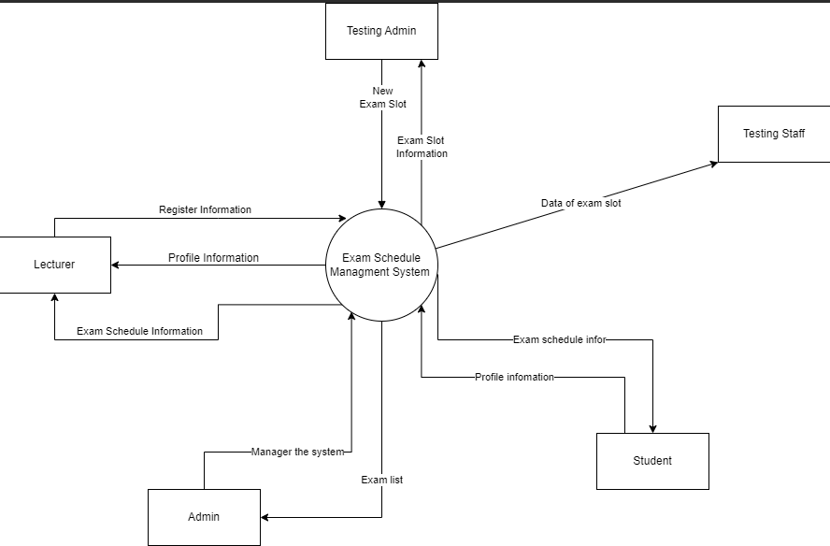

[Swimlane Diagram - Google Drive](https://drive.google.com/drive/folders/1a1lPiwb-OGpW7EINhkQ1gGcAGSCWwin1?fbclid=IwAR08YnmNmydvY8f0eWFUxis3nEbcmr0Run6AJOe4Hn0aVTBBSPPnnc9VVfM)

# **SLOT 12: Sequence Diagram**

[Sequence Diagram - Google Drive](https://drive.google.com/drive/folders/1hN0rN5TabLLBIHOXXI5MDO8kHnmuUY3x?fbclid=IwAR08YnmNmydvY8f0eWFUxis3nEbcmr0Run6AJOe4Hn0aVTBBSPPnnc9VVfM)

# **SLOT 13: State Machine**

[State Machine - Google Drive](https://drive.google.com/drive/folders/1NF9ovpjJwrBnKAk5BIUoKU6NKlatcZv0?fbclid=IwAR08YnmNmydvY8f0eWFUxis3nEbcmr0Run6AJOe4Hn0aVTBBSPPnnc9VVfM)

# **SLOT 14, 15: ERD, Class Diagram**

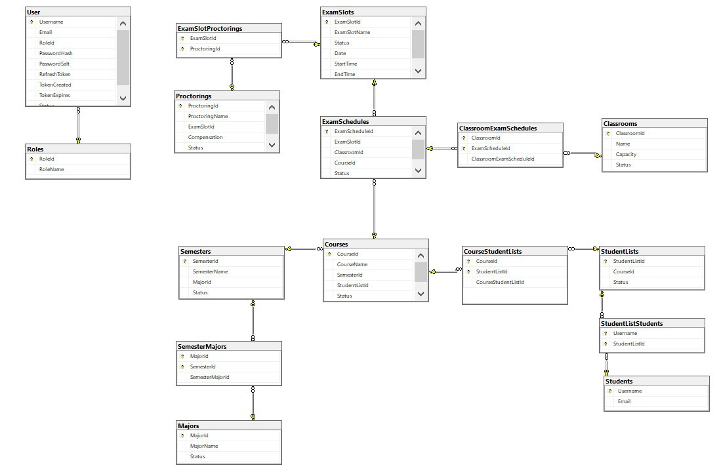

**Data Dictionary for Exam Schedule Management System**

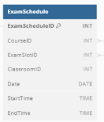

| **Data Element** | **Description** | **Composition or Data Type** | **Length** | **Values** |
| --- | --- | --- | --- | --- |
| ExamSchedule | View the exam schedule | ExamScheduleID  + CourseID  + ExamSlotID  + ClassroomID  + Date  + StartTime  + EndTime |  |  |
| *Exam*ScheduleID | *Identify ID of exam schedule* | Integer |  | Integer |
| CourseID | *Course exam code* | Integer |  | Integer |
| ExamSlotID | *Code of Slot() that takes place the test* | Integer |  | Integer |
| ClassroomID | *room code where the test is taking place* | Integer |  | Integer |
| Date | *the date of the exam* | Date | (e.g., MM/DD/YYYY) | MM/DD/YYYY |
| StartTime | *Time start for exam* | Time | (e.g., HH:MM AM/PM) | HH:MM AM/PM |
| EndTime | *Time end for exam* | Time | (e.g., HH:MM AM/PM) | HH:MM AM/PM |

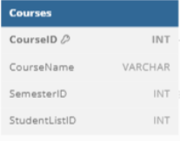

| **Data Element** | **Description** | **Composition or Data Type** | **Length** | **Values** |
| --- | --- | --- | --- | --- |
| CourseID | Identify ID of each course in database | Integer | 5 |  |
| CourseName | Identify Name of each course in database | String |  |  |
| SemesterID | Identify ID of each semester in database | Integer | 5 |  |
| StudentListID | Identify ID of each student in a student catalogue in database | Integer | 5 |  |

Nhân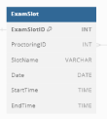

| **Data Element** | **Description** | **Composition or Data Type** | **Length** | **Values** |
| --- | --- | --- | --- | --- |
| ExamSlot | Exam Slot data | Exam Slot ID Protoring ID SlotName Date StartTime EndTime |  |  |
| ExamSlotID | Define the ID of each ExamSlot | Integer | 5 |  |
| ProctoringID | An ID of each Proctoring join to the ExamSlot | Integer | 5 |  |
| SlotName | Name of slot | String |  |  |
| Date | Define Date of ExamSlot | MM/DD/YYYY |  |  |
| StartTime | Define start time of examslot | HH/MM |  |  |
| EndTime | Define end time of examslot | HH/MM |  |  |

Huấn

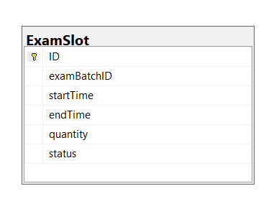

| **Data Element** | **Description** | **Composition or Data Type** | **Length** | **Values** |
| --- | --- | --- | --- | --- |
| ID | Exam Slot Identifier | Integer |  | Unique numerical identifier |
| examBatchID | Exam Batch Identifier | Integer |  | Unique numerical identifier |
| startTime | Start Time of Exam | Date and Time |  | Date and time in a specific format |
| endTime | Start Time of Exam | Date and Time |  | Date and time in a specific format |
| quantity | Quantity of Examiner who can regist this slot | Integer |  | Positive whole number |
| status | Exam Slot Status | Boolean |  | Option “true” or “false” |

CRUD matrix

Class Diagram

Loc_register Protoring

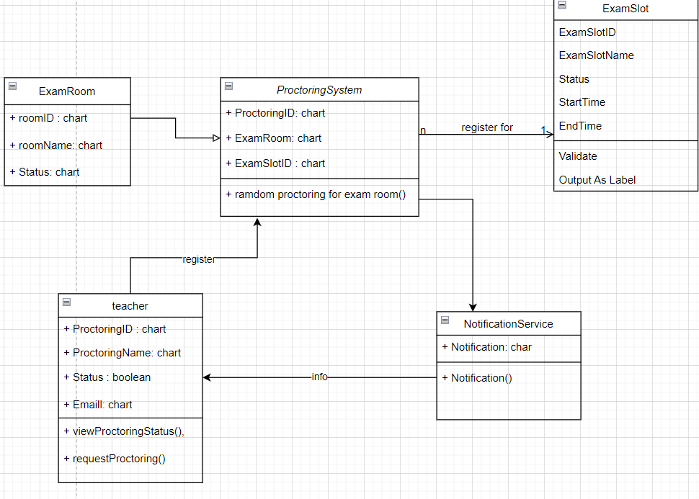

# **SLOT 16: ASSIGNMENT 2 (PRESENTATION CHAPTER 21)**

1. What is project?
2. What type of documents regarding this project?
3. How to elicit requirements in this project? (methods to elicit requirements)
4. What are the specific tasks of BA in this project? **(When old requirements don’t exist)**

* Reverse-engineer an understanding of what the system does from the user interfaces, code, and database.
* Record what is learned in the form of requirements and design descriptions.
* Accumulate accurate information about certain portions of the current system to enhance a system with low risk, replace a system without missing critical functionality, and perform future enhancements efficiently.
* Update requirements documentation when changing or re-creating software.
* Extend fractional knowledge representations over time to improve system documentation.
* Add new requirements to an existing requirements repository if there is one.
* Document the requirements for a new system and keep them up-to-date with what is learned throughout the project.

Chương 21 nha

<https://www.canva.com/design/DAFyGJcMtpI/8t3Ag1IYEOS0pn1l4tzyKQ/edit>

# **SLOT 18: Software Requirements Specification (SRS)**

[Software Requirements Specification Template.docx - Google Docs](https://docs.google.com/document/d/1V2yoxeQBUxoZ8QXT31xb0sO85pljrApr/edit)